**MY GYM AFTER DECORATION**

IT WAS SO BORED, BUT WITH A LITTLE HELP…

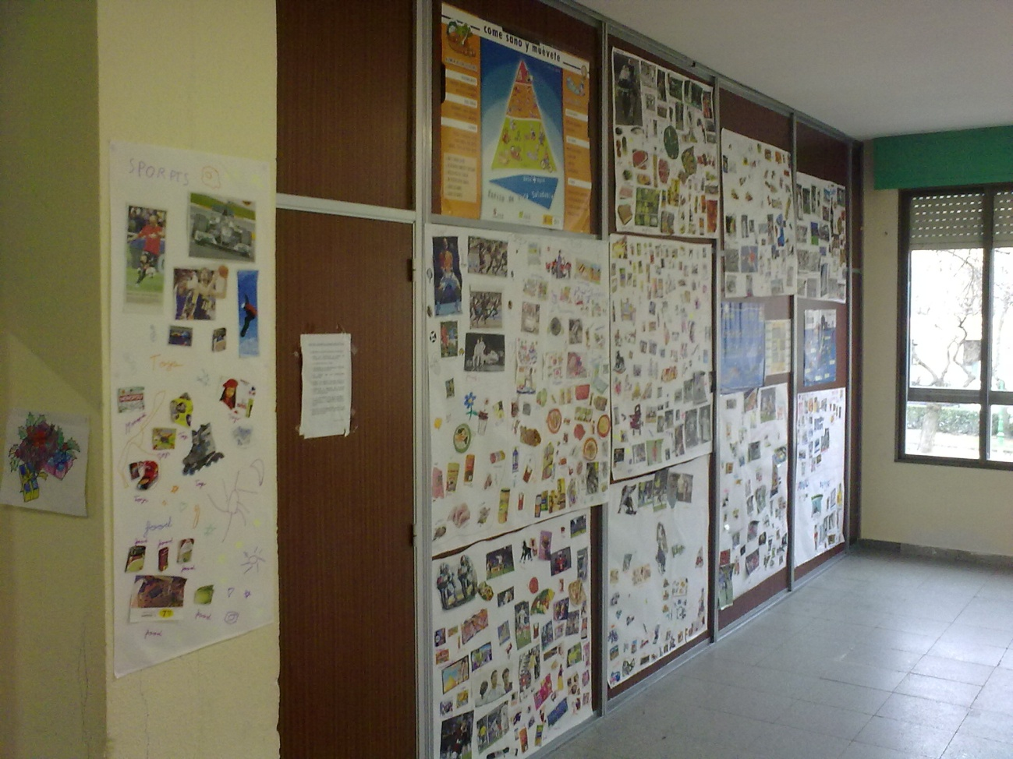

GUYS HAVE DONE A GOOD JOB…

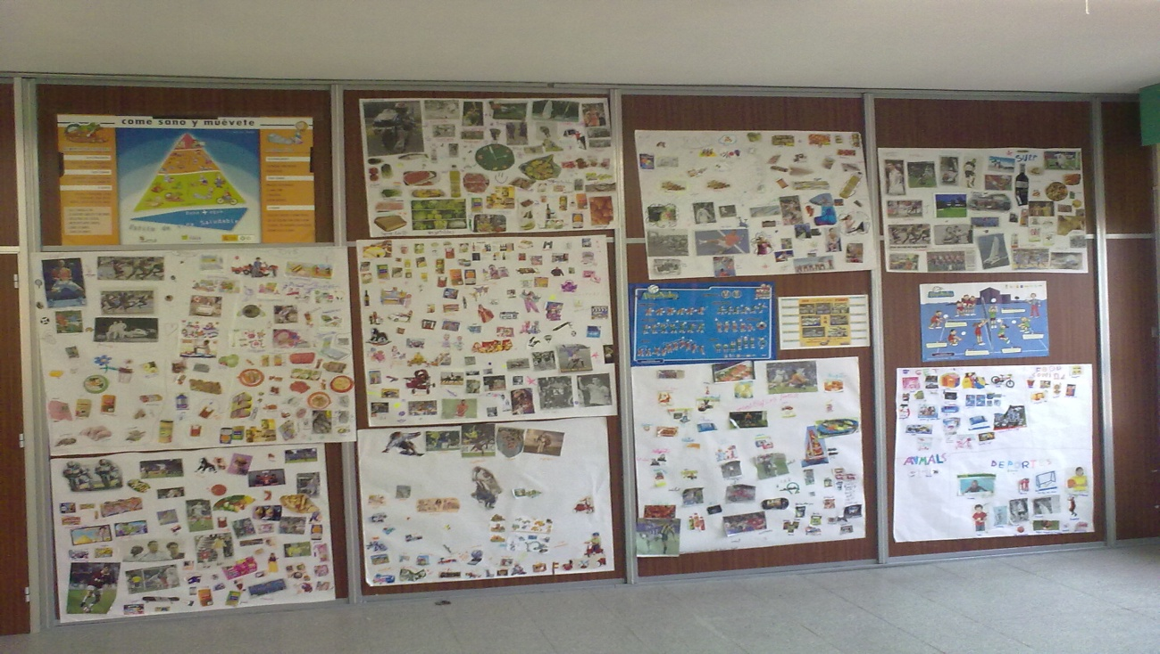

AT FIRST TIME, WALLS WERE WHITE OR BROWN, LIKE ALWAYS…

HOWEVER…I EXPLAINED THE KIDS WHAT THEY SHOULD DO:

* THEY HAVE TO CHOOSE THE GROUPS (2 GROUPS), AND THEY HAVE TO BRING TO THE CLASS PHOTOS (SPORTS, FOOD AND TOYS-GAMES)
* WHEN THEY WERE READY, THEY MUST GLUE THESE PHOTOS ON THE BIG PAPER AND PUT THE NAMES OF THE THINGS IN ENGLISH.
* AT THE END OF THE ACTIVITY, ALL OF US SPOKE ABOUT IT, AND TRIED TO LOOK FOR RELATIONS AMONG THESE PHOTOS.
* OTHER ACTIVITY WAS WITH 5 YEARS KIDS…THEY MUST PAINT THINGS ABOUT PEACE AND SPORTS WITH MANY COLOURS. THESE MURALS WERE DECORATED WITH YELLOW STARTS AND DIFFERENT PICTURES.

**START**

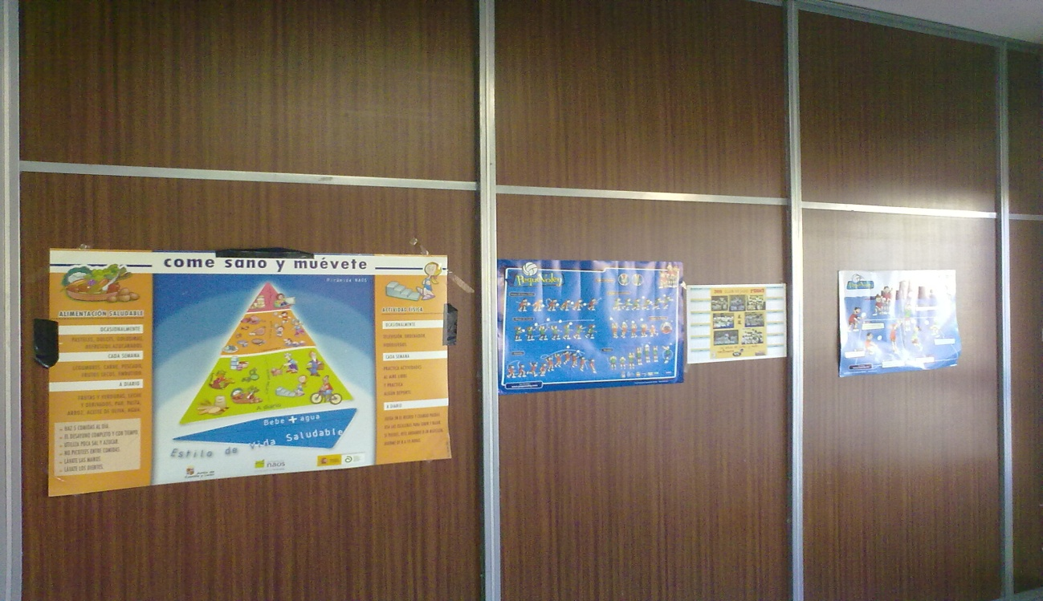

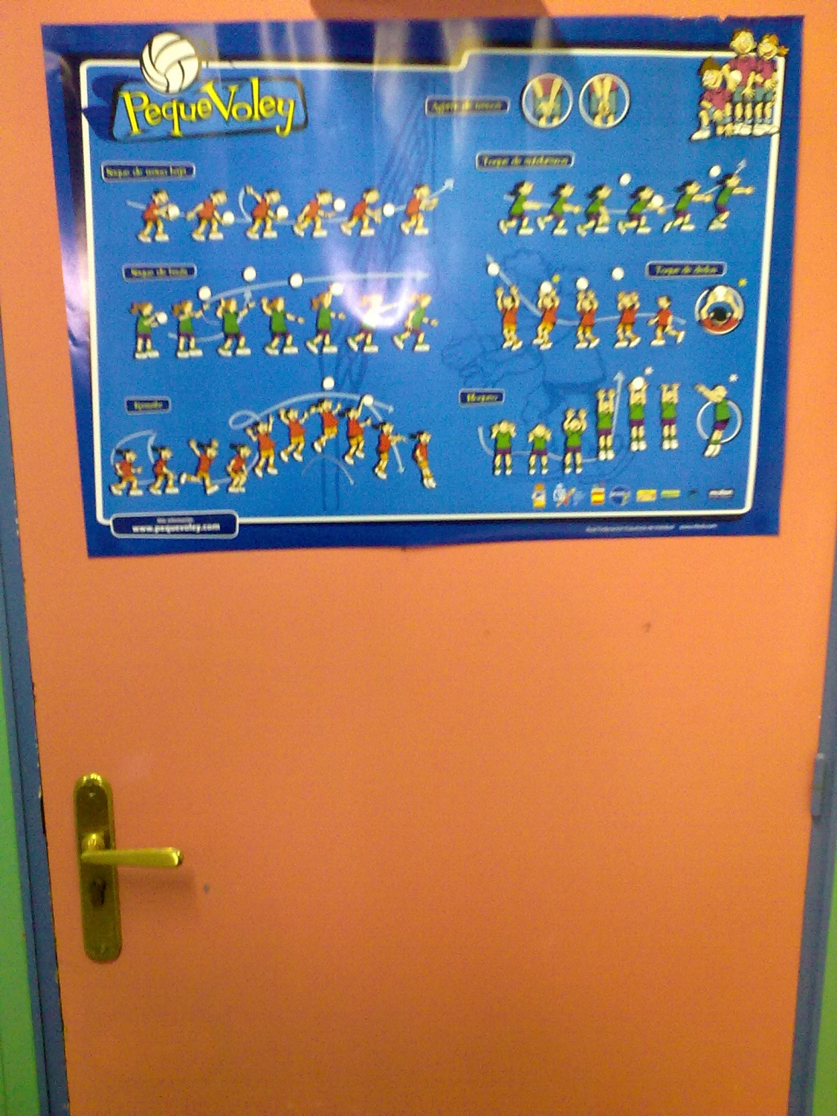

**5 YEARS JOB**

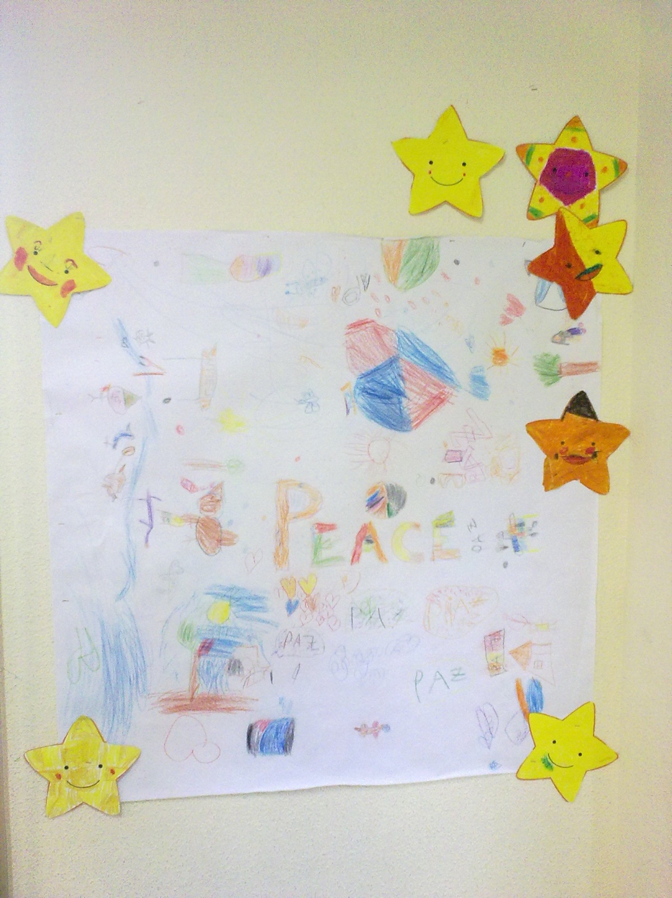

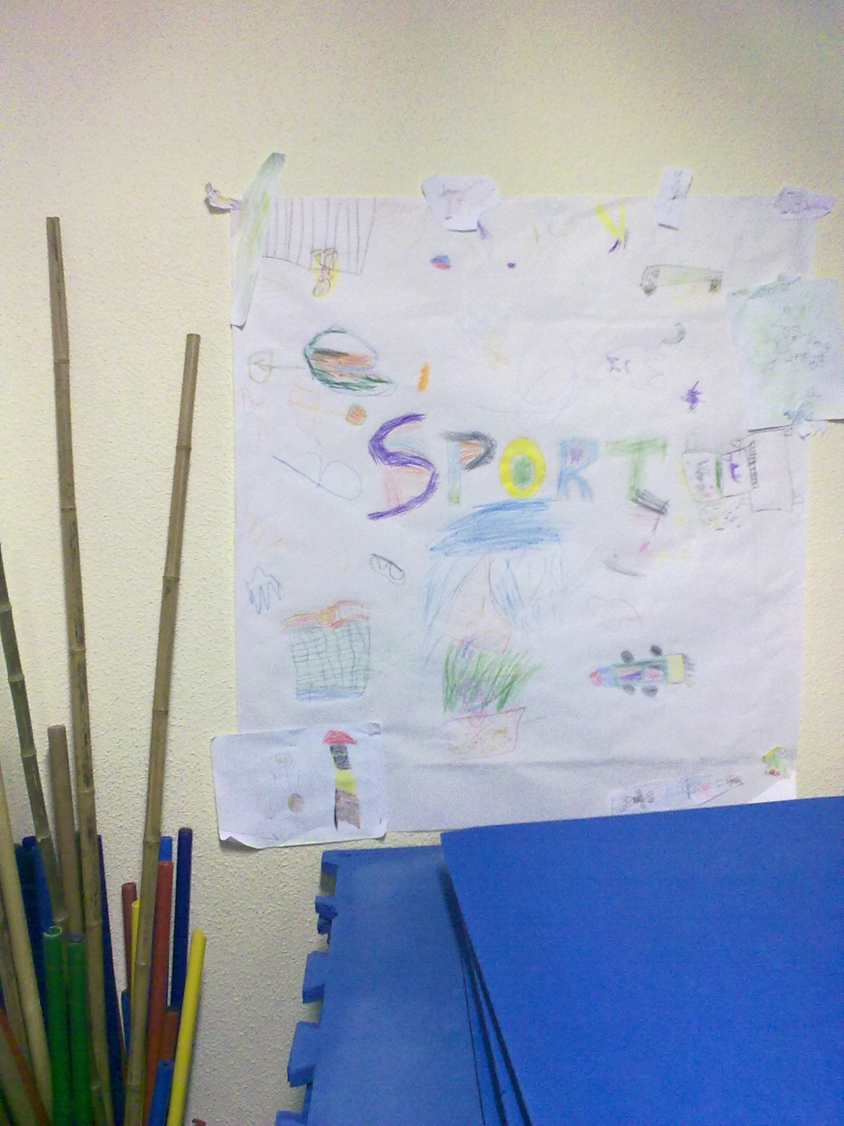

**FIRSTS MURALS**

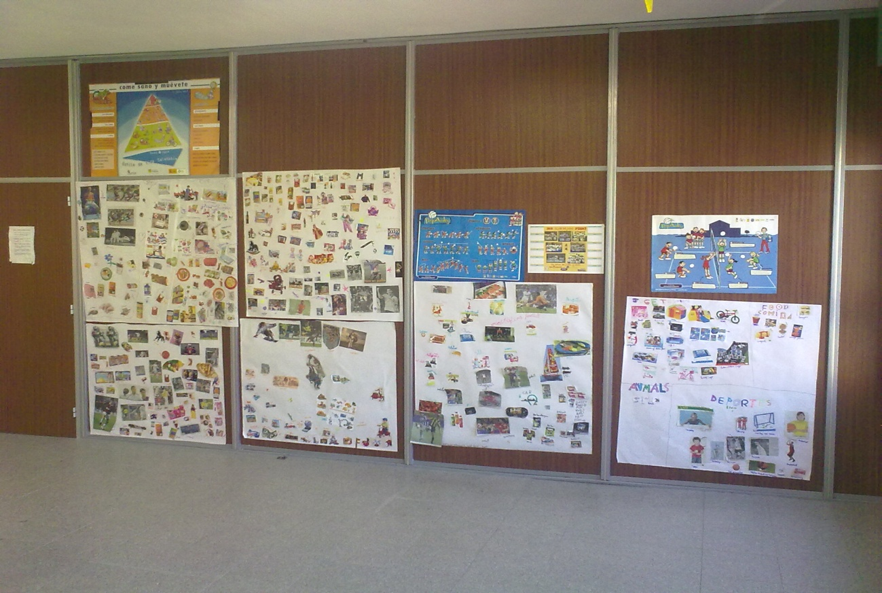

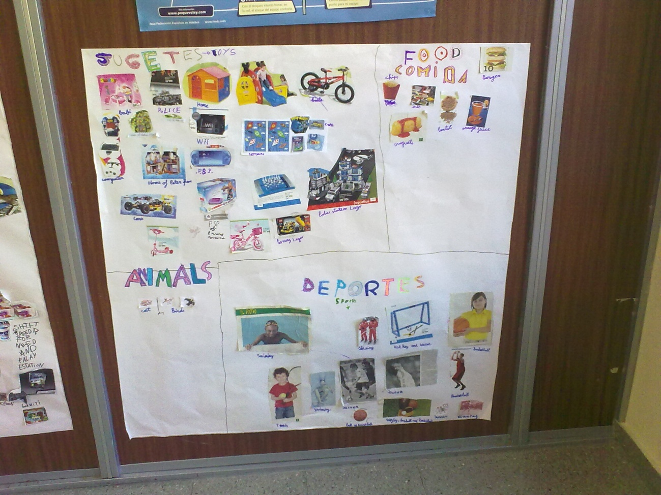

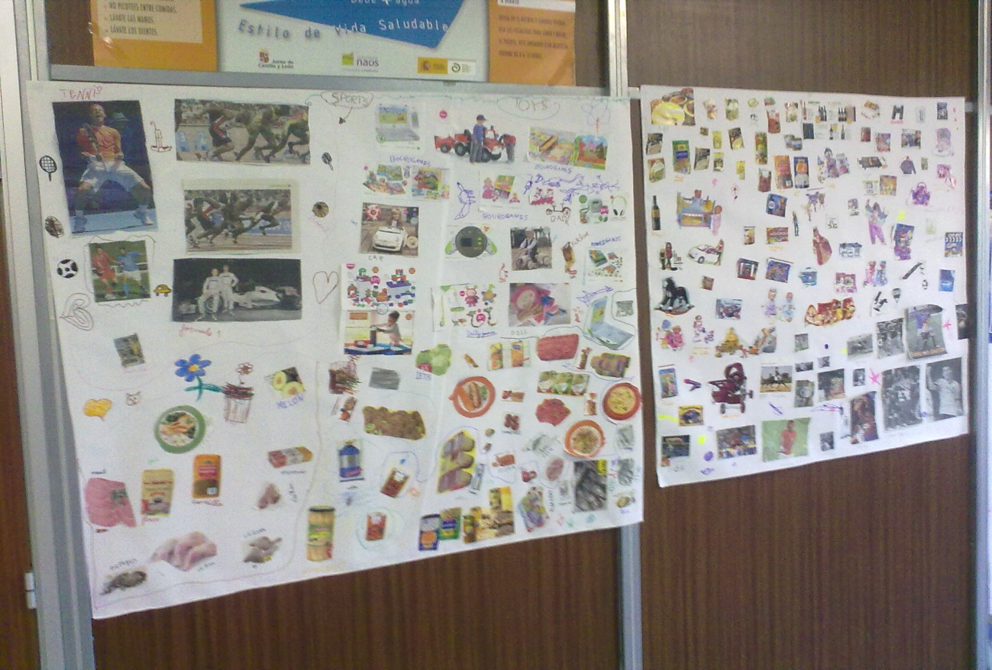

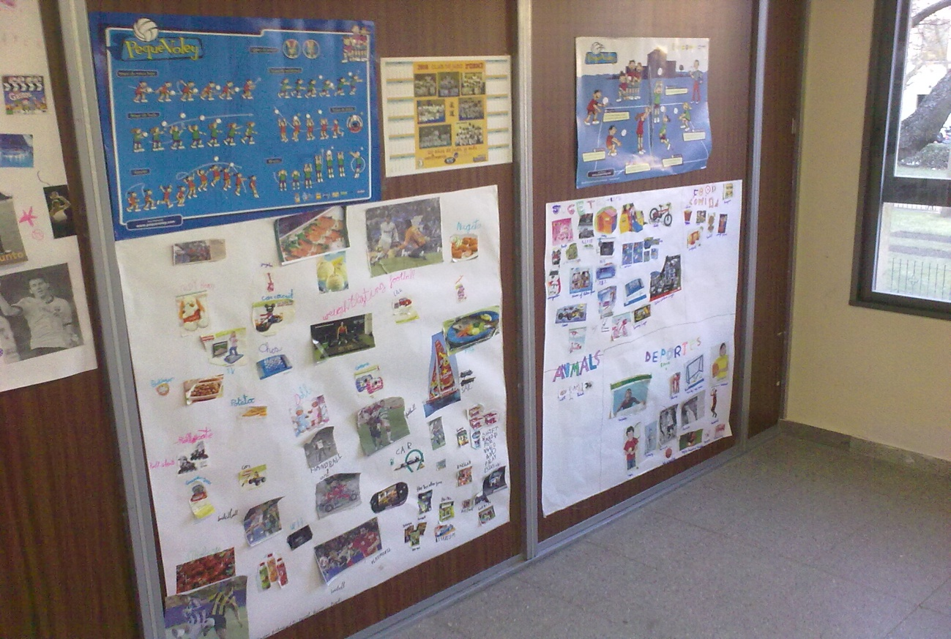

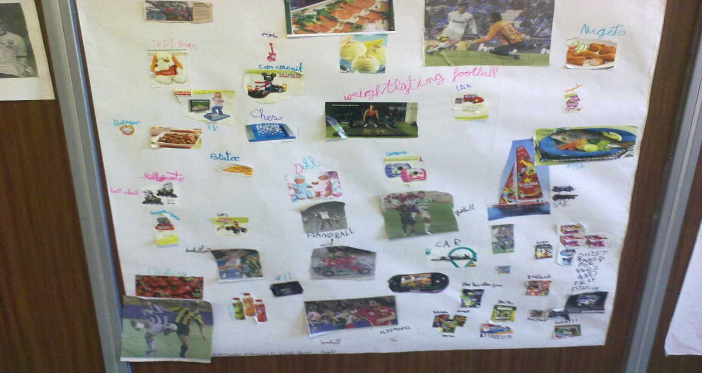

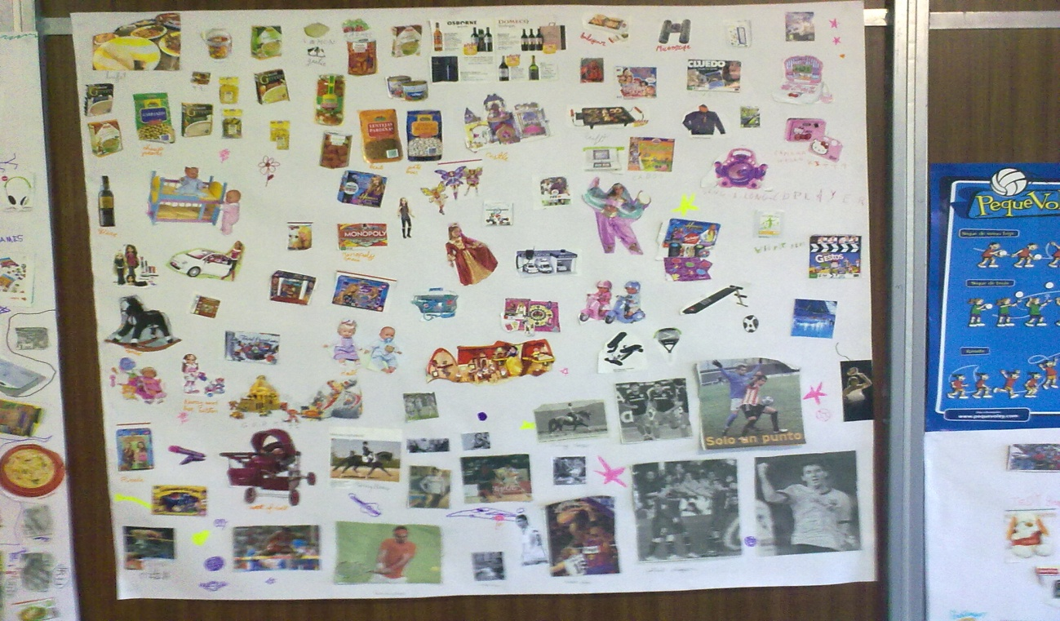

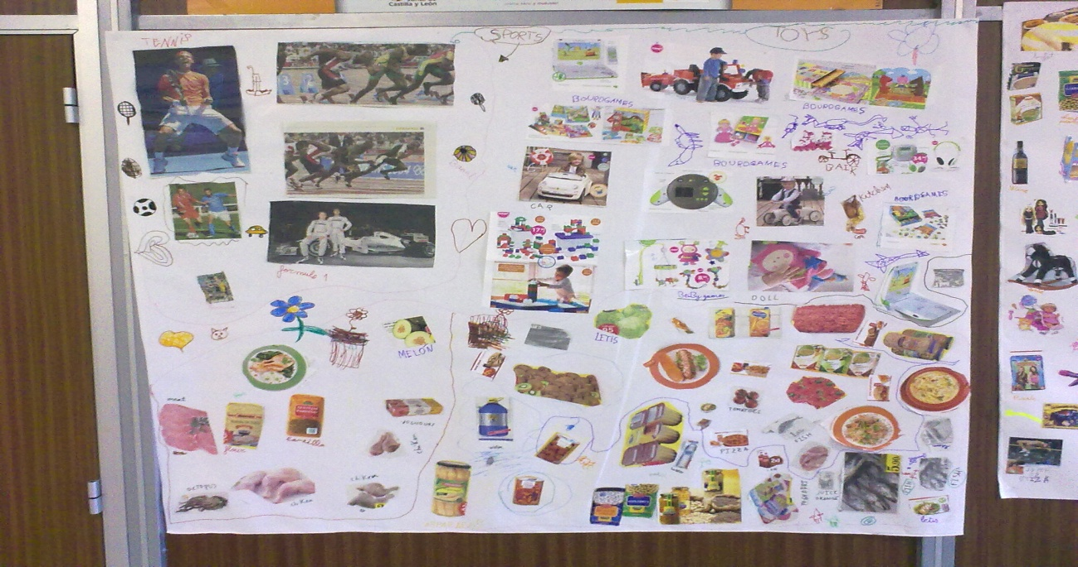

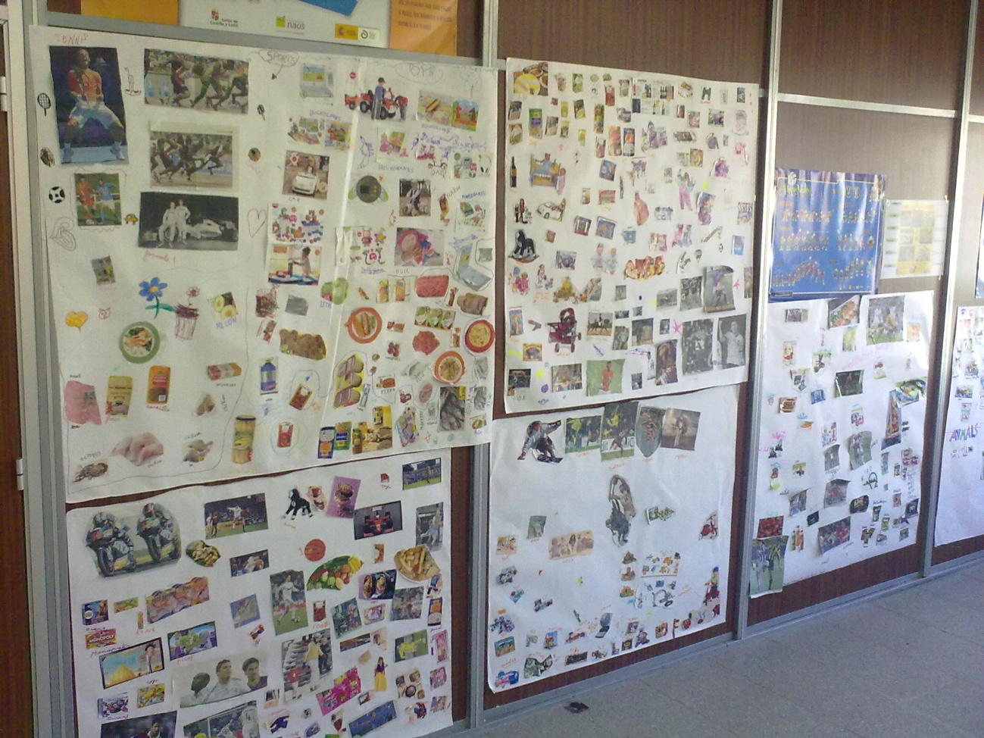

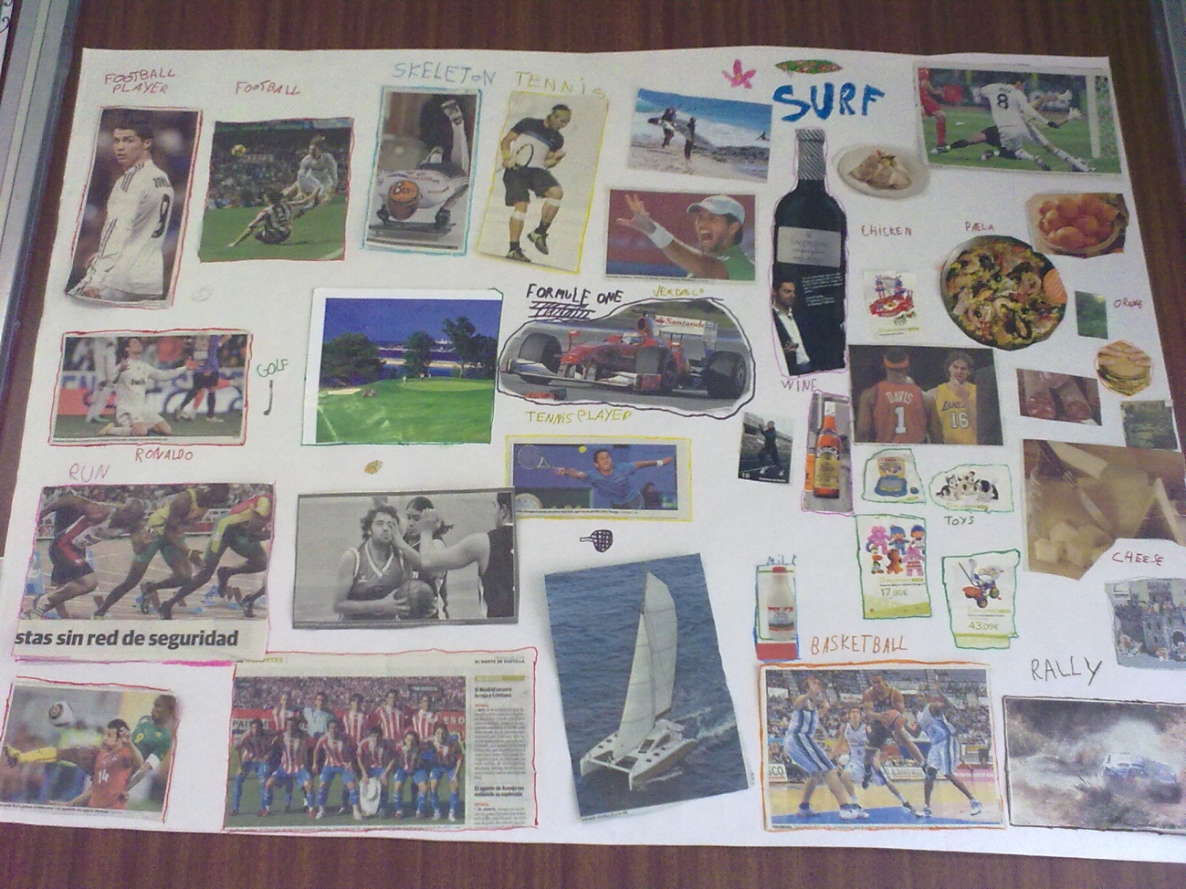

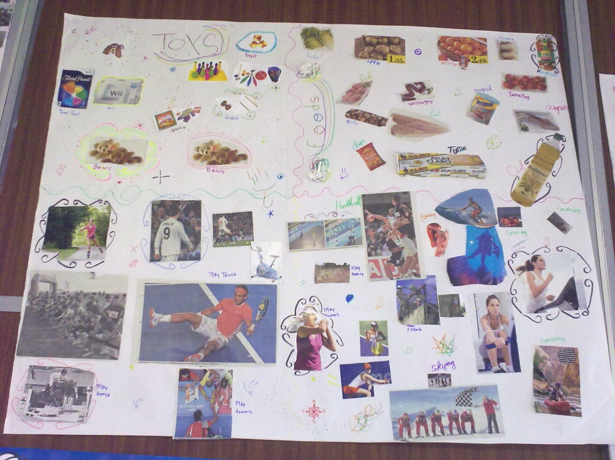

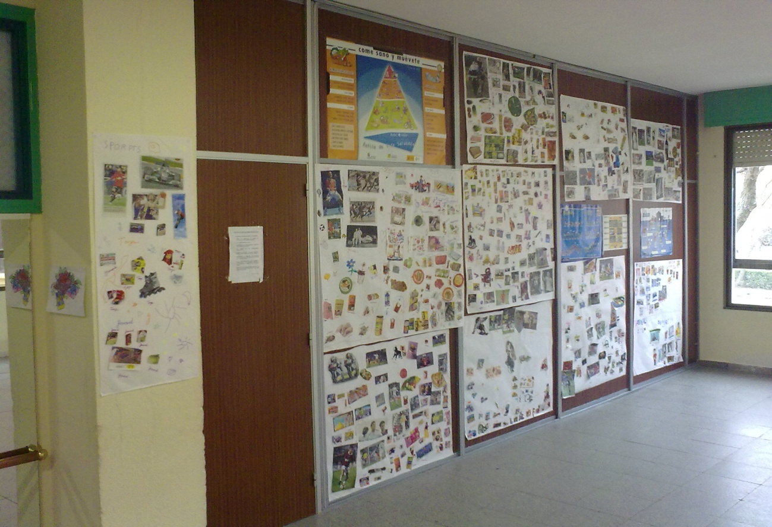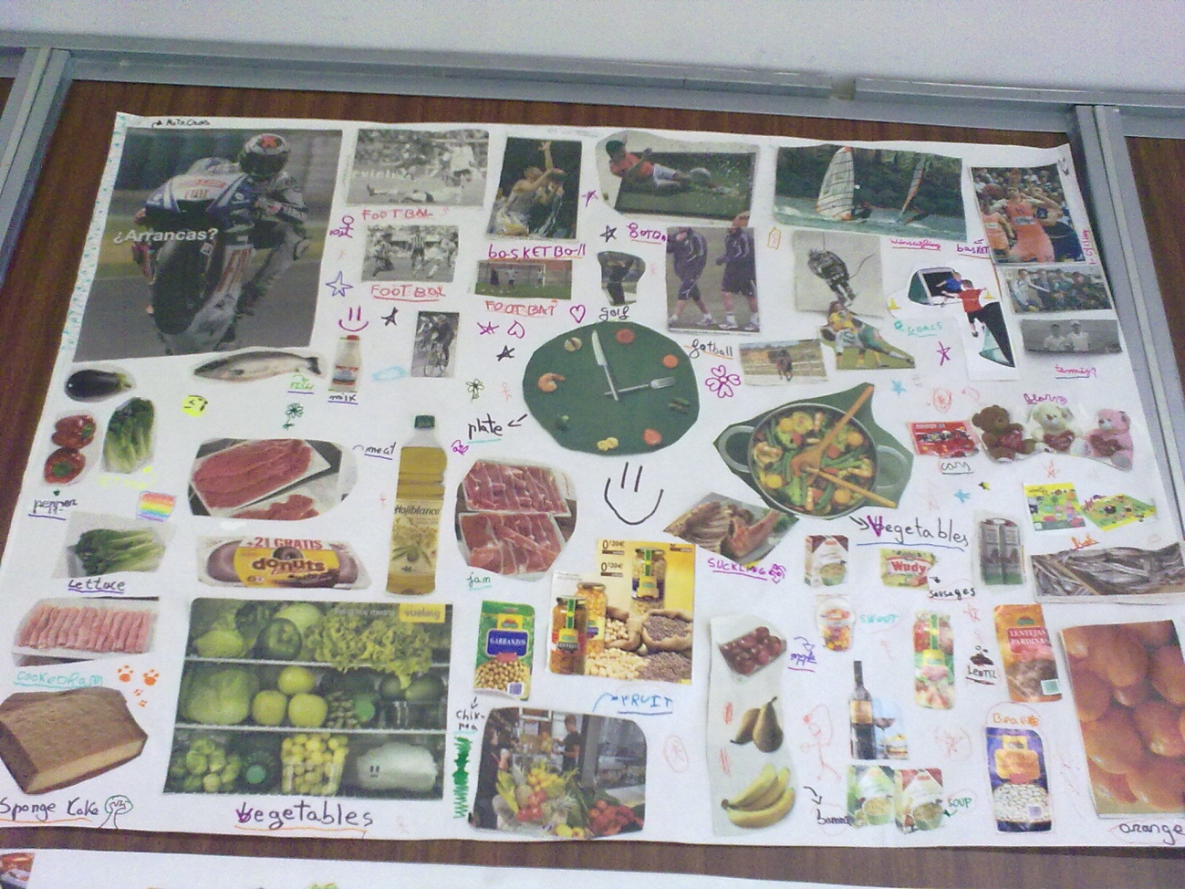

**LATER THEY HAVE TO FILL THESE MURALS**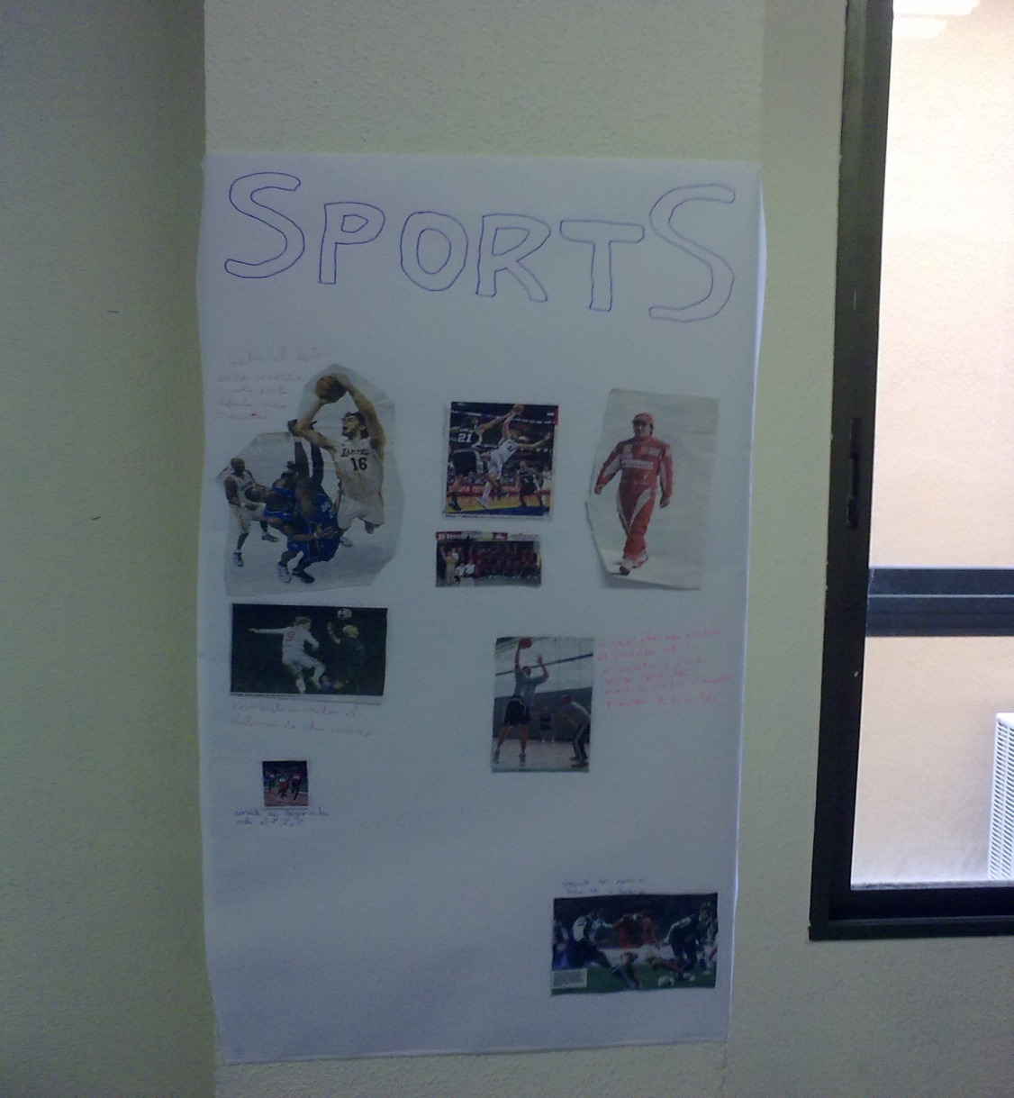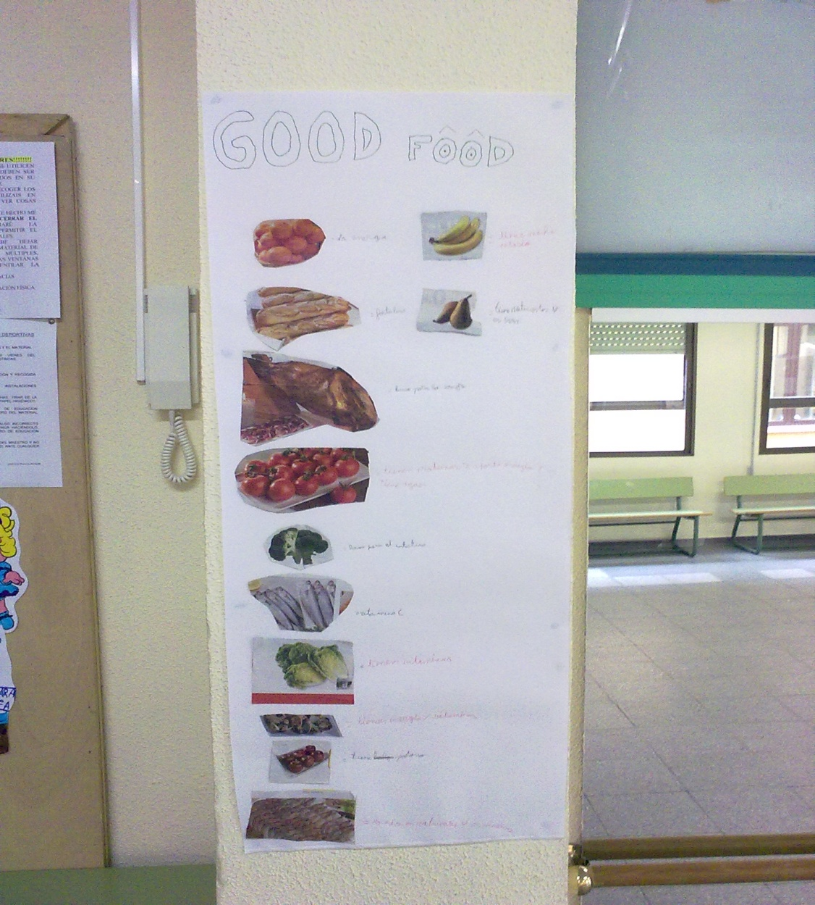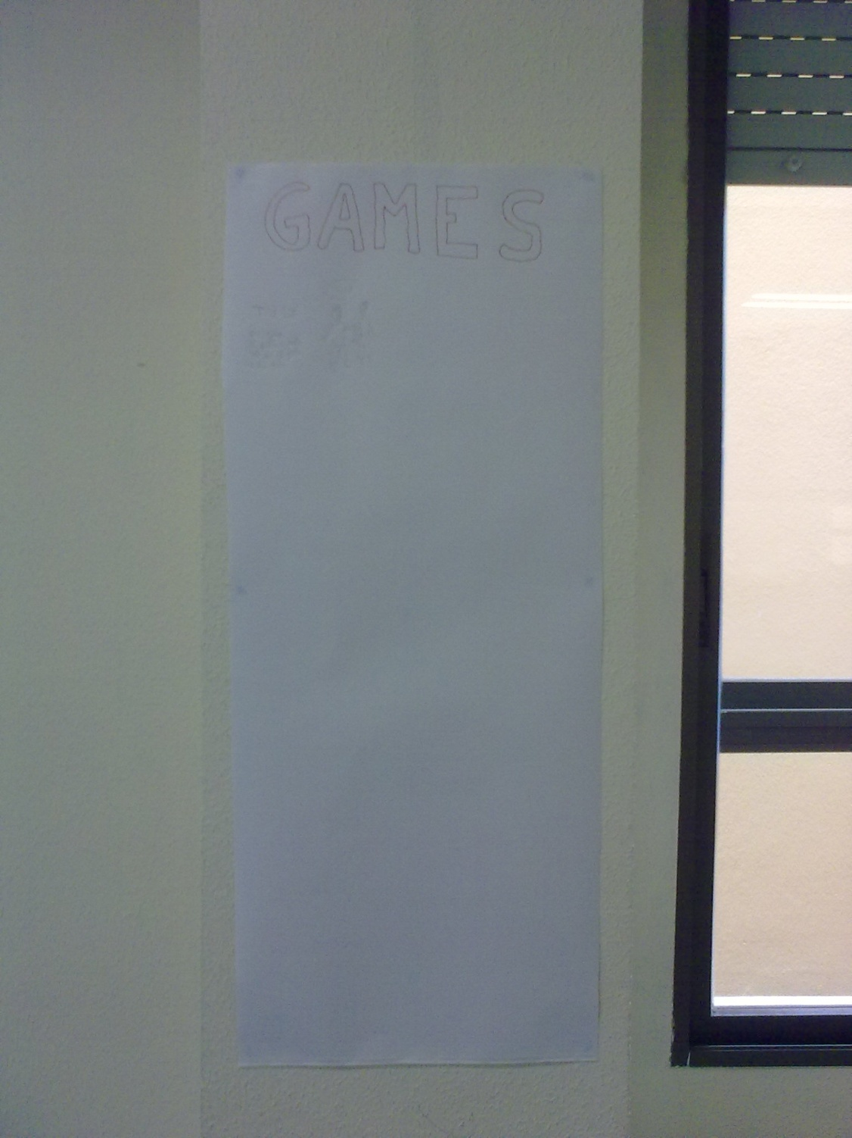

**THE END**